G. Deep Dive Into a Key Gene: EGFR
1. Functional Overview and Disease Relevance (NCBI Gene Summary)
The Epidermal Growth Factor Receptor (EGFR), also known as HER1 or ERBB1, is a transmembrane glycoprotein belonging to the protein kinase superfamily. EGFR functions as a receptor for ligands in the epidermal growth factor family. Upon ligand binding, EGFR undergoes receptor dimerization followed by tyrosine autophosphorylation, which activates multiple downstream signaling cascades that promote cell proliferation, survival, and differentiation.
Mutations and dysregulation of the EGFR gene are a well-established driver of non-small cell lung cancer (NSCLC), particularly lung adenocarcinoma (LUAD). Due to its central oncogenic role, EGFR represents one of the most important therapeutic targets in LUAD.
2. PANDA Network Analysis: Differential Regulatory Targeting
Using PANDA network inference, we observed a dramatic rewiring of transcriptional regulation targeting EGFR in LUAD compared to normal GTEx lung tissue. Specifically, the regulatory connection strength (Force) directed toward EGFR shows substantial changes, indicating a fundamental shift in its transcriptional control program in cancer.
The table below summarizes transcription factors (TFs) with the largest absolute change in targeting strength toward EGFR:
Rank | Transcription Factor  (TF) | Force  (LUAD) | Force  (GTEx) | Δ Targeting  (LUAD − GTEx) | Implication
1 | ZNF334 | 1.289 | -0.302 | +1.590 | Highly enhanced targeting in LUAD
2 | ZNF384 | 1.310 | -0.280 | +1.590 | Highly enhanced targeting in LUAD
3 | ZNF25 | 1.216 | -0.343 | +1.559 | Enhanced targeting in LUAD
4 | FOXS1 | 1.293 | -0.260 | +1.554 | Enhanced targeting in LUAD
5 | ARID3A | 1.024 | -0.524 | +1.547 | Enhanced targeting in LUAD
These results demonstrate a concerted regulatory shift driven primarily by zinc finger proteins (ZNF334, ZNF384, ZNF25) and FOX family transcription factors. Their significantly increased targeting suggests that these TFs act as key drivers of aberrant EGFR upregulation in LUAD.
This pattern is summarized visually in Figure 1, where TFs are separated into increased vs decreased targeting of EGFR in LUAD.

Figure 1. EGFR regulatory rewiring in LUAD
Differential transcription factor (TF) targeting of EGFR inferred by PANDA network analysis. Bars represent changes in TF→EGFR edge weights between LUAD and normal GTEx lung tissue (Δ targeting = force_{LUAD} − force_{GTEx}). Positive values indicate increased regulatory influence on EGFR in LUAD.
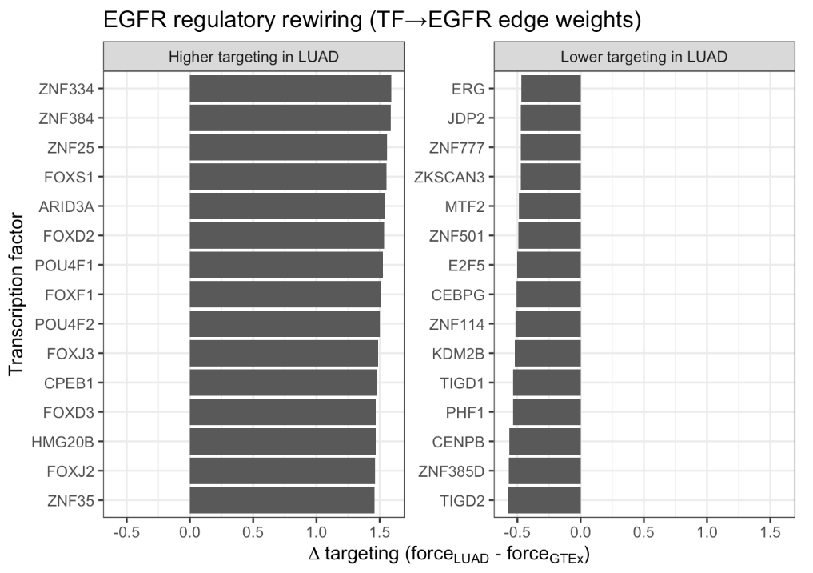

3. UCSC Genomic Context Supports Regulatory Rewiring (GRCh38 / hg38)
To investigate the physical basis underlying the observed network rewiring, we examined the genomic context of the EGFR locus using the UCSC Genome Browser.
3.1 Genomic Features of EGFR
- Chromosomal location: Chromosome 7p11.2
- Gene structure: EGFR contains 32 exons
3.2 Regulatory Evidence from ENCODE
The most compelling evidence for enhanced regulatory activity comes from the ENCODE H3K27ac histone modification track, which marks active promoters and enhancers. The UCSC Genome Browser shows:
- Strong, high-intensity H3K27ac peaks at the canonical promoter region (Transcription Start Site, TSS)
- Extended H3K27ac enrichment in upstream and intronic regulatory regions
3.3 Interpretation
The presence of robust H3K27ac signals indicates that the EGFR locus is surrounded by highly accessible and transcriptionally active regulatory elements. The increased PANDA targeting by TFs such as ZNF334 and FOXS1 is likely enabled by their enhanced binding to these active enhancer regions in LUAD. This provides a mechanistic explanation for the observed transcriptional rewiring and elevated EGFR expression.
4. Functional Consequences of Regulatory Rewiring (Secondary TF-Specific GSEA)
To understand the broader functional impact of EGFR-targeting TFs, we performed TF-specific Gene Set Enrichment Analysis (GSEA) focusing on TFs such as ARID3A and FOXF1. A global overview of significant TF–pathway associations is shown in Figure 2, highlighting coordinated shifts in regulatory programs.

Figure 2. Pathway-level consequences of TF regulatory rewiring
Heatmap summarizing significant KEGG pathway enrichments from TF-specific gene set enrichment analysis (GSEA). Normalized enrichment scores (NES) reflect shifts in regulatory targeting by rewired TFs in LUAD relative to GTEx lung. Only TF–pathway associations passing global BH-adjusted significance thresholds are shown.
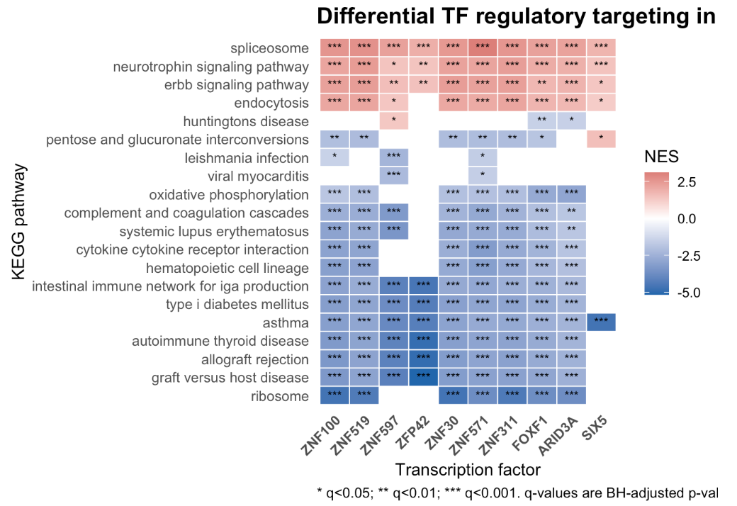
4.1 Metabolic and Translational Reprogramming
TFs showing high Δ Targeting toward EGFR exhibited significantly reduced targeting of basal cellular pathways, including:
- KEGG_RIBOSOME: NES ≈ −3.7;q-value < 1 × 10⁻²⁰
- KEGG_OXIDATIVE_PHOSPHORYLATION: NES ≈ −2.9;q-value < 1 × 10⁻¹⁰
This suggests a global regulatory shift away from cellular housekeeping functions toward pro-proliferative and oncogenic programs.
In addition to metabolic and translational pathways, multiple immune and inflammatory pathways (e.g., cytokine–cytokine receptor interaction, complement/coagulation cascades, and allograft rejection-related gene sets) show broadly negative NES across rewired TFs, suggesting a coordinated reduction of immune/homeostatic regulatory targeting in LUAD. Conversely, positive enrichment of ERBB signaling and endocytosis-related pathways is consistent with a shift toward receptor tyrosine kinase–associated programs, aligning with enhanced EGFR regulatory targeting in the tumor network.
4.2 Signal Maintenance and Protein Stability
Notably, the transcription factor FOXF1 displayed significantly enhanced targeting of the:
- KEGG_UBIQUITIN_MEDIATED_PROTEOLYSIS pathway: NES ≈ +2.25; q-value ≈ 4.8 × 10⁻⁹
Ubiquitination plays a critical role in regulating receptor tyrosine kinases, including EGFR, by controlling protein degradation and signal termination. The rewired regulation of this pathway suggests a coordinated mechanism that may modulate EGFR stability or prolong signaling duration, further promoting uncontrolled cell growth.
To make these pathway shifts more concrete, Figure 3 summarizes the most significant enriched KEGG pathways for representative highly rewired TFs.
Figure 3. Representative TF-specific pathway enrichments
Bubble plots showing enriched KEGG pathways for representative highly rewired transcription factors. The x-axis indicates BH-adjusted p-values (global), bubble size corresponds to pathway gene-set size, and color represents the normalized enrichment score (NES), with positive and negative values indicating increased or decreased targeting in LUAD.

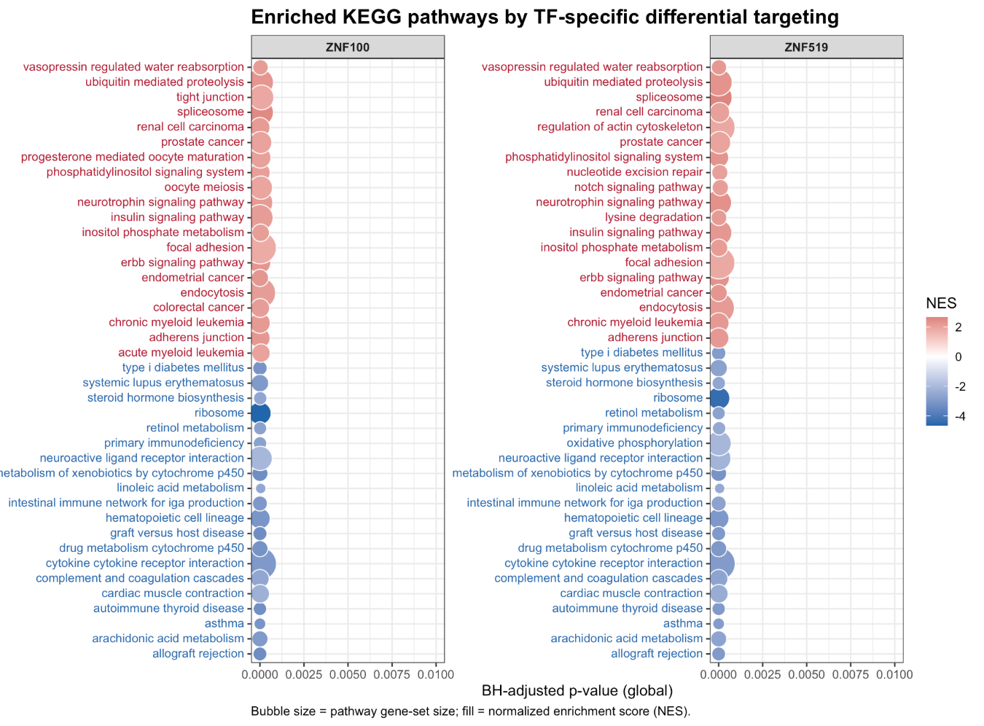
5. Integrated Conclusion
By integrating network inference, functional pathway analysis, and genomic context, we provide a cohesive explanation for the role of EGFR in LUAD pathogenesis:
- Direct Regulatory Drivers:
A specific subset of transcription factors (e.g., ZNF334, ZNF384) shows dramatically increased regulatory influence on EGFR in LUAD.
- Genomic Mechanism:
This enhanced influence is physically supported by H3K27ac-marked active enhancers surrounding the EGFR locus, enabling stronger TF binding and transcriptional activation.
- Coordinated Oncogenic Program:
The same TFs that upregulate EGFR also globally rewire pathways related to protein degradation, metabolism, and translation, reshaping the cellular environment to sustain malignancy.
Overall, EGFR contributes to LUAD not only through its intrinsic oncogenic signaling but also as a central hub within a massively reorganized transcriptional regulatory network.

